AI-Based Native Language Identification System for Communication Support: Breaking Language Barriers Through Intelligent Assistance

Kyla H. Baguio
Department of Computer Engineering
Polytechnic University of the Philippines
Paranaque City, Philippines
kylahbaguio@iskolarngbayan.pup.edu.ph
Aimie Cris B. Raotraot
Department of Computer Engineering
Polytechnic University of the Philippines
Paranaque City, Philippines
aimiecrisbraotraot@iskolarngbayan.pup.edu.ph
*Mikaela N. Del Monte
Department of Computer Engineering
Polytechnic University of the Philippines
Paranaque City, Philippines
mikaelandelmonte@iskolarngbayan.pup.edu.ph
Jefferson A. Costales
Department of Polytechnic University of the Paranaque City Philippines
Paranaque City, Philippines
jeacostales@pup.edu.ph
Mary Dionne M. Obrador
Department of Computer Engineering
Polytechnic University of the Philippines
Paranaque City, Philippines
marydionnemobrador@iskolarngbayan.pup.edu.ph

Abstract—Native Language Identification (NLI) is a system designed for automatic identification of the mother tongue of a person based on the way of communication of another foreign language. This study introduces an application with an embedded Support Vector Machine for machine learning that is very versatile in distinguishing two or more different foreign languages. It also has the application programming interface (API) of Deepgram Nova-3, which has a build of incredibly fast and accurate AI knowledge specifically for speech-to-text. Then we use RoBERTa-based, as it has a highly powerful natural language processing model built to support contextual inputs or meanings of human language.
This application not only identifies their native language but also has an automotive translator to ease their struggle with the language barrier. This study connects the NLI and machine translation to create a real-time, personalized communication tool that offers new insights into multilingual deep learning and cross-lingual communication.
Keywords—Machine Translation System, Native Language Identification, Application Programming Interface, Natural Language Processing, RoBERTa-Base.

I. Introduction
Language is still one of the biggest barriers we face to mobility, economic opportunities around the world, and cross-cultural exchanges. According to the World Tourism Organization, due to the increasing number of international tourists globally, they estimated that by the year 2030, there will be 1.8 billion tourist arrivals worldwide, and so too will the number of people migrating from country to country (overseas employment has been increasing) [1].
Being able to communicate with others who speak different languages can be an important factor in enabling their successful participation. Despite having various advancements in terms of technology aligned with machine translation and natural language processing (NLP), there are still many complexities of multi-language exchanges that cannot be effectively handled by existing machine translation and NLP technology.
To solve this matter that some travelers and business owners are experiencing, researchers study the functionality and effectiveness of native language identification (NLI). It is traditionally focused on determining a person’s first language that can be recognized from their written text using another language, primarily with system applications in forensic stylometry, authorship attribution, and second language acquisition research [2] There are demonstrations from recent works that large transformer models such as GPT-2 can have an accurate result of 94% in NLI tasks when applied to text [3]. Even after surface-level grammatical correction, deeper linguistic elements like lexico-semantic choices, pragmatic transfer, and cultural perspective endure. Demonstration from these results shows
that L1 traces contain the speaker's underlying conceptual and cultural framework in addition to error patterns [4].
While NLI research is going on, massive progress has been made in machine translation systems. Neural Machine Translation (NMT) models are now powering real-time communication tools in a wide range of domains, from healthcare to tourism and education [5][6]. Such tools, however, generally adopt a "one-size-fits-all" approach: they translate speech without considering the speaker's native language background and thus produce output that may be linguistically correct but pragmatically incorrect. The lack of linguistically diverse benchmarks and the challenge of cross-lingual transfer have been identified as constraints in studies on multilingual task-oriented dialogue systems [7], while reviews of contextual translation accuracy show continuing problems with idiomatic expressions, cultural nuance, and domain-specific terminology [1]
There is still a huge gap between research studies despite the connection between the two fields. Even if NLI system can identify a user's native language and a machine translation system can automatically translate between languages they use, there is still no integrated framework that combines adaptive communication support with native language identification.
The aim of this system is to detect the native language of a user from spoken or written input and adapt communication assistance such as translation, simplification or clarification on the fly to break the language barrier in real-time.
II. Related works
Over the past few years, Artificial Intelligence (AI) has emerged to improve communication support systems in many ways, especially by providing automatic language identification systems, such as Native Language Identification (NLI). Numerous studies have been made to use AI techniques, data engineering, and model training by identifying a native language of a person through speech-based datasets and text-based datasets in different scenarios.
[8] showed that GPT-2 fine-tuning with a few hundreds of NLI data can seriously improve the update of NLI through rich and underlying contextual linguistic patterns. In the transformer-based methodology used in this study, embeddings from the last three blocks of BERT were extracted by using the NLI-PT dataset. In the study, the results indicate that the methods attain a state-of-the-art accuracy of 94.65% and weighted F1 score of 0.9419, surpassing the conventional classifiers for SVM, Random Forest, and even BERT-based classifiers by large margins. These findings prove the superior capability of large-scale generative models in identifying native language interference within learner corpora.
Starting with audio signals, researchers built a tool to spot which Indian language someone is speaking. Instead of relying on just one type of sound data, they merged two kinds - tone patterns and frequency details. This blend fed into a statistical model known as a Hidden Markov Model [9]. Each snippet of speech was turned into a 14-part numerical summary before processing. Tests covered five major regional tongues: Hindi, Telugu, Kannada, Malayalam, and Marathi. On average, the method correctly labeled the spoken language nearly 97 times out of 100 attempts. Using both rhythm and melody cues helped tell them apart more reliably, given that some languages share sounds similar.
[10] demonstrated that combining multiple string kernels significantly improves native language identification (NLI), achieving a state-of-the-art accuracy of 85.3% on the TOEFL11 dataset. They find that by combining a number of both character and word n-grams, in the lengths 2 -> 5, the model melts many larger topical patterns with small idiosyncratic features that are undetected by either signal alone. Although the system performs exceptionally well in general classification, results indicate that the most difficult task for kernel-based techniques is still differentiating between linguistically similar languages.
[11] showed that regional accents from South India have distinct acoustic distributions, and MFCC captures the vocal tract features. Experimental data from the Kannada, Tamil and Telugu speech corpora showed that for the i-vector modeling paradigm a peak classification accuracy of 94% is achieved, remaining the traditional GMM frameworks far behind. The findings also indicate that prosodic features, particularly pitch contour variations, serve as reliable discriminators for identifying native language influence on English speech. Consequently, the study concludes that a combination of spectral and excitation source features provides a robust foundation for automatic regional nativity identification.
[12] demonstrates that a dual attention mechanism can improve language identification (LID) performance, which relies on local spatial features and temporal speech dependencies. In summary, referring to the experimental results on the Common Voice and AP17-OLR datasets, spectrograms are the best input feature since they keep most of the original auditory information which therefore outperforms MFCC and FBank. The superiority of the proposed CNN-CBAM-BiGRU model is also observable, attaining peak accuracy rates of 88.21% and 96.44% on the respective datasets, compared to standard CNN and CNN-CBAM-BiLSTM architectures. In addition, using channel attention before spatial attention in the CBAM achieves the highest recognition rates.

III. Proposed System approach

System Description
This study presents LINGUA, a Linguistic Identification & Native Guide for Universal Assistance that infers the first language (L1) background of speakers from their second language (L2) English utterances across two input modalities: speech and text-based chat. Both inputs are routed through a unified RoBERTa-based classification pipeline, with the frontend built on Node.js and AI inference served through a FastAPI backend. This architecture separates client-side concerns from model inference, allowing each layer to scale independently while keeping latency low for real-time interaction.
The dataset is sourced from a publicly available spoken dialogue corpus of general conversational interviews with Asian learners of English. Seven native language regions were selected as classification targets: Filipino (PHL), Thai (THA), Chinese (CHN), Japanese (JPN), Korean (KOR), Pakistani (PAK), and Indonesian (IDN). These regions were chosen because they represent linguistically distinct L1 backgrounds whose phonological, syntactic, and lexical transfer patterns in L2 English are sufficiently differentiated to support automated classification.

Data Preprocessing and Feature Engineering
The raw corpus underwent five sequential cleaning steps. First, the Turn column was stripped of inconsistent whitespace to prevent valid [S] speaker turns from being silently excluded, retaining only respondent utterances while discarding all interviewer turns. Second, a regular expression pipeline removed transcription artifacts like bracketed markers, parenthetical annotations, and angle-bracket tags, thus eliminating 25 empty rows of post-cleaning. Third, utterances fewer than 3 words were dropped, removing 17,703 rows insufficient in L1 signal. Fourth, 81 exact duplicate utterances were discarded to prevent data leakage. Fifth, regional labels were integer-encoded as PHL=0 through IDN=6. The resulting dataset comprised 22,064 utterances across 7 regions.
Utterances are tokenized using RoBERTa's BPE tokenizer at a maximum of 128 tokens — sufficient for short conversational utterances and significantly lighter than the model's 512-token limit. Tokenization is performed lazily per sample at retrieval time, avoiding the out-of-memory errors caused by pre-loading all 42,638 training tensors simultaneously on a 6GB GPU.

Native Language Identification Model
The classification model is RoBERTa-based, selected for its strong contextual text representation and computational efficiency relative to larger transformer variants, making it well-suited for deployment on hardware with limited VRAM.
The pre-trained language modeling head was replaced with a randomly initialized 7-class sequence classification head trained from scratch on the NLI task while the underlying transformer weights were fine-tuned. To accommodate a 6GB GPU, a per-device batch size of 4 was used with 4 gradient accumulation steps, maintaining an effective batch size of 16. Mixed-precision training (FP16) and gradient checkpointing were enabled to reduce memory consumption, allowing the 125M-parameter model to train without memory errors. The learning rate was set to 2e-5 with 200 warmup steps and a weight decay of 0.01 for regularization.
Training ran for a maximum of 5 epochs with early stopping applied after 2 consecutive epochs without improvement in validation accuracy, restoring the best-performing checkpoint at termination. A weighted cross-entropy loss function was additionally applied to penalize minority-class misclassifications, providing a secondary correction layer alongside oversampling for any residual class imbalance within training batches.

System Architecture
The system follows a two-tier architecture designed to separate client interaction from model inference. The Node.js frontend manages user-facing interactions and routes inputs to the FastAPI backend, which was chosen for its asynchronous request handling and compatibility with Python-based ML inference. Speech inputs are first transcribed via Deepgram Nova-3, whose high transcription accuracy preserves L1-influenced speech patterns in the resulting text. The transcript is then forwarded to the shared Language Identifier module for RoBERTa-based classification. Chat inputs bypass the transcription step entirely and are passed directly to the same module, ensuring both modalities converge on a single, consistent classification path. Both paths return a structured JSON response containing the source modality, transcript, predicted native language region, and confidence score.
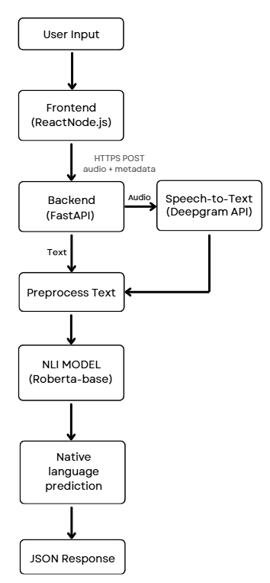

Figure 1. Two-tier Model Architecture

Scope and Limitation
The study covers the development of a Native Language Identification system utilizing a fine-tuned RoBERTa transformer classifier trained on ICNALE transcribed interview utterances, targeting seven L1 classes (Filipino, Mandarin Chinese, Japanese, Korean, Indonesian, Thai, and Pakistani/Urdu) integrated into a web-based application for real-time multilingual communication support in service-counter interactions. The system is restricted to the seven predefined language classes due to classification accuracy may degrade for very short utterances, highly proficient speakers, and linguistically similar language pairs such as Japanese and Korean.

System Evaluation
Performance will be measured using per-class precision, recall, F1-score, and overall accuracy on the held-out test set under its original unbalanced distribution. Separate evaluations across speech and chat inputs will assess cross-modality performance parity, alongside response latency benchmarks to confirm real-time suitability.

IV. Results and discussion
The LINGUA system shows the ability to perform well in identifying the native language of the users by their English text or voice inputs. The system uses a combination of AI such as the Deepgram API, RoBERTa model, and support vector machine algorithms embedded in a FastAPI backend to analyze linguistic patterns in user inputs to have an accurate result of their native language background while they use the system.
The system needs enough input length for the system to be able to have a reliable analysis. With this, it successfully identifies native languages across the seven languages' linguistic background (Chinese, Indonesian, Japanese, Korean, Pakistani, Philippine, and Thai). The results illustrate an overall accuracy of 89%, with macro-averaged F1-score of 0.89, demonstrating that the system effectively recognizes native language markers in English inputs across diverse multilingual user populations. This outcome highlights the system's effectiveness in supporting automatic language detection and enabling personalized responses tailored to users' linguistic backgrounds. This makes a convenient NLI tool for the user because the system can dynamically adjust its translation parameters, anticipate specific vocabulary confusion, and provide almost seamless, user experience without requiring manual configuration.

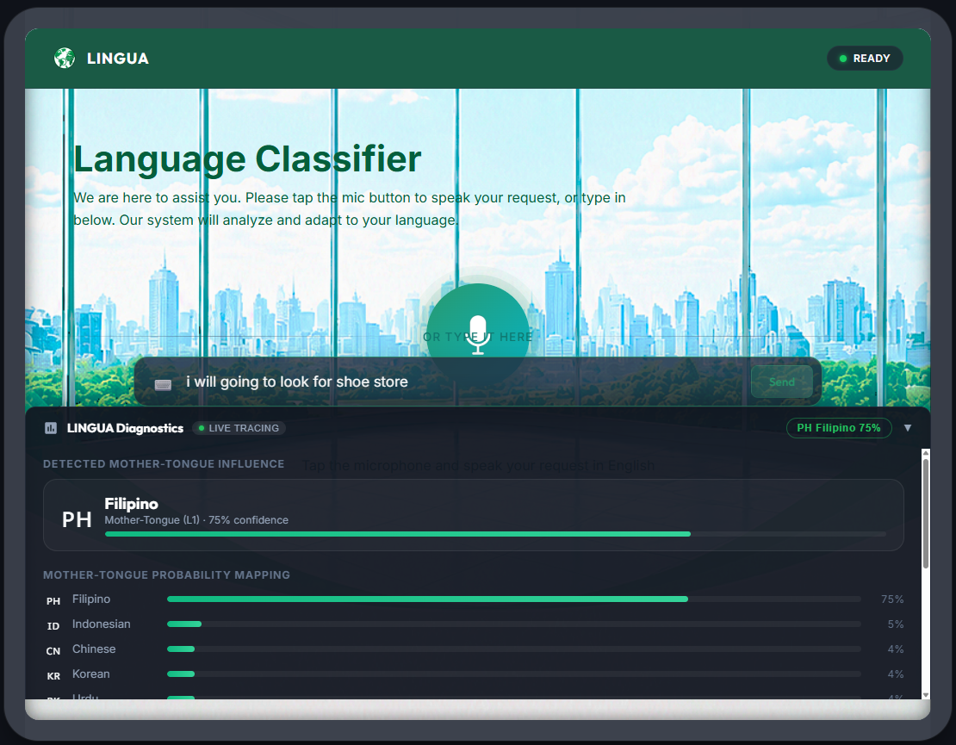Figure 2. Language Classifier
Figure 2 shows the language classifier where the users can choose either input text or voice speech for tracing their native language. When the user inputs text, the system will evaluate the user’s grammar and linguistic features, and then after 3 seconds the system will provide a diagnostic report where it shows the user’s mother tongue and the confidence level. While in the voice speech, the user may also tap the mic icon for their request. It’s the same process for inputting text, but the difference is that in voice speech the system will evaluate the user’s accent and speech pattern.
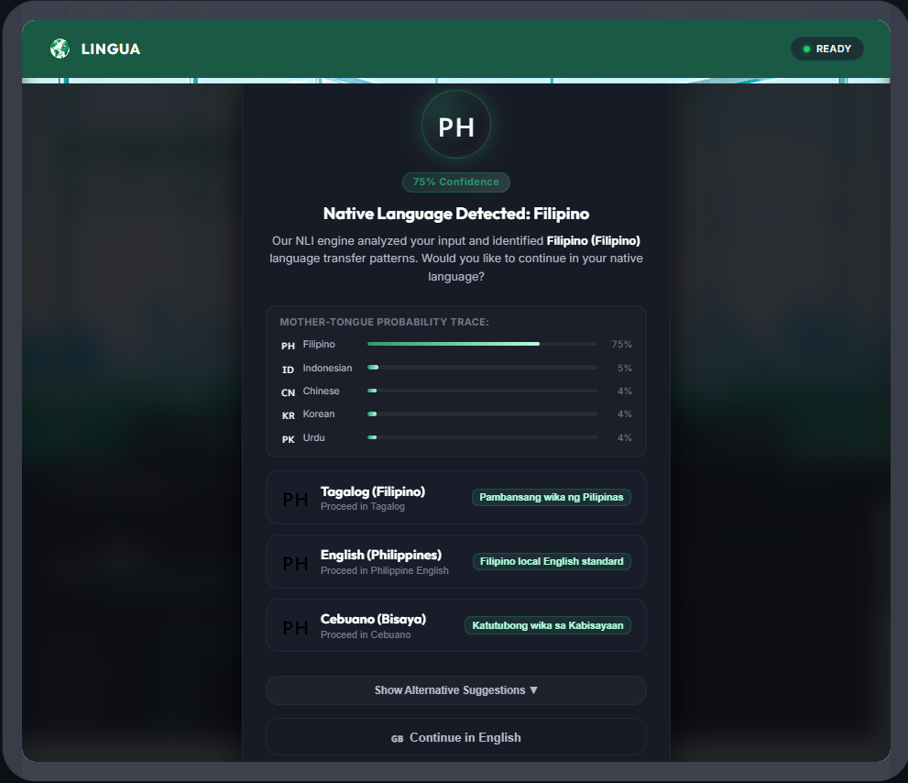Figure 3. Language Suggestions
Figure 3 illustrates the language suggestions, which appear after the system has analyzed the user’s native language, providing diagnostic reports and confidence levels. Based on the highest-probability language region detected, the system also provides localized language options to the user. In addition, the user may also click the alternative suggestion or continue using the English language.

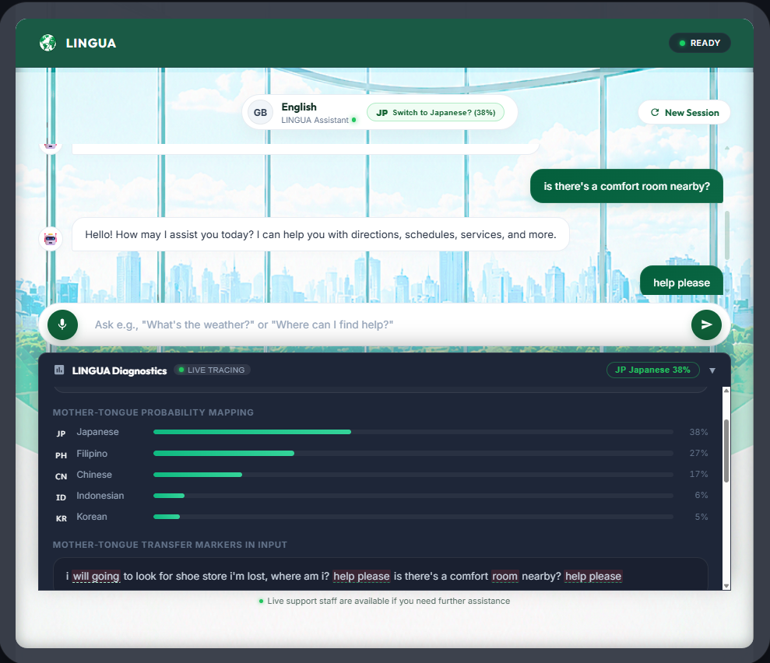Figure 4. NLI Live Tracing while ongoing chats are happening
In Figure 4, after the system identifies the native language and provides the localized language options to the user, it will proceed to the chat screen. The language of the system will shift according to what the user chooses from the language options. While the chats are ongoing, the language tracer will continue to identify the user’s inputs and will suggest new identified language depending on the results. They can still switch the language of the system while they are using it according to their preferences from the suggested languages. Once the user is satisfied with the service and has no more questions. They can click the new session, and the system will return from the language classifier interface so other users can use it and be analyzed too.

V. Conclusion

In conclusion, language barriers remain one of the challenges travelers faces across the world. Despite the studies conducted to provide technological solutions for overcoming language differences, existing machine learning (ML) tools still struggle to fully handle the complexity of the different languages. Therefore, this study introduces a Native Language Identification (NLI) python-based tool with the assistance of Machine Learning (ML), to improve communication efficiency by identifying a user’s native language through speech and written text. To develop the proposed system, the Deepgram API is utilized to support speech-to-text features while also training the RoBERTA-base model using the spoken dialogue datasets. The FastAPI was integrated for the backend framework, while Node.js was used for the frontend. The dataset used consisted of English utterances from seven distinct Asian countries as the regions have linguistically distinct L1 background making it suitable for testing.

The system performs automatic speech recognition, native language recognition, generated analytics report, provides localized language options, and a user-defined translation. Moreover, it achieved an 89% accuracy in identifying native language patterns from user’s English spoken dialogues. Consequently, this study helps reduce language misunderstanding and enhances communication among individuals from different regions. For future researchers, this study recommends integrating a more advanced model that supports Speech-to-text functionality and handles short utterances, to further improve the system’s accuracy, effectiveness, and reliability for users.

References
[1] P. Naveen and P. Trojovský, “Overview and challenges of machine translation for contextually appropriate translations,” Oct. 18, 2024, Elsevier Inc. doi: 10.1016/j.isci.2024.110878.
[2] D. Goswami, S. Thilagan, K. North, S. Malmasi, and M. Zampieri, “Native Language Identification in Texts: A Survey,” in Proceedings of the 2024 Conference of the North American Chapter of the Association for Computational Linguistics: Human Language Technologies, NAACL 2024, Association for Computational Linguistics (ACL), 2024, pp. 3149–3160. doi: 10.18653/v1/2024.naacl-long.173.
[3] Y. Nie, “Native language identification from text using a fine-tuned GPT-2 model,” PeerJ Comput. Sci., vol. 11, 2025, doi: 10.7717/peerj-cs.2909.
[4] A. Y. Uluslu, M. Gales, K. Knill, and G. Schneider, “The Impact of Editorial Intervention on Detecting Native Language Traces,” May 2026, [Online]. Available: http://arxiv.org/abs/2605.10216
[5] A. Kreienbrinck, S. Hanft-Robert, A. I. Forray, A. Nozewu, and M. Mösko, “Usability of technological tools to overcome language barriers in healthcare– a scoping review,” Dec. 01, 2025, BioMed Central Ltd. doi: 10.1186/s13690-025-01543-1.
[6] S. Kolar and R. Kumar, “Multilingual Tourist Assistance using ChatGPT: Comparing Capabilities in Hindi, Telugu, and Kannada,” Jul. 2023, [Online]. Available: http://arxiv.org/abs/2307.15376
[7] E. Razumovskaia, G. Glavaš, O. Majewska, E. M. Ponti, A. Korhonen, and I. Vulić, “Crossing the Conversational Chasm: A Primer on Natural Language Processing for Multilingual Task-Oriented Dialogue Systems,” 2022.
[8] Y. Nie, “Native language identification from text using a fine-tuned GPT-2 model,” PeerJ Comput. Sci., vol. 11, 2025, doi: 10.7717/peerj-cs.2909.
[9] M. Sadanandam, “HMM based language identification from speech utterances of popular indic languages using spectral and prosodic features,” Traitement du Signal, vol. 38, no. 2, pp. 521–528, Apr. 2021, doi: 10.18280/ts.380232.
[10] V. K. Gurram, J. Sanil, V. S. Anoop, and S. Asharaf, “String Kernel-Based Techniques for Native Language Identification,” Human-Centric Intelligent Systems, vol. 3, pp. 402–415, Sep. 2023, doi: 10.1007/s44230-023-00029-z.
[11] R. K. Guntur, K. Ramakrishnan, and V. K. Mittal, “Automatic Classification of Foreign Language Accent,” in 2021 2nd Global Conference for Advancement in Technology, GCAT 2021, Institute of Electrical and Electronics Engineers Inc., Oct. 2021. doi: 10.1109/GCAT52182.2021.9587650.
[12] M. Ablimit, M. Xueli, and A. Hamdulla, “Language Identification Research Based on Dual Attention Mechanism,” in 2021 IEEE 2nd International Conference on Pattern Recognition and Machine Learning, PRML 2021, Institute of Electrical and Electronics Engineers Inc., Jul. 2021, pp. 241–246. doi: 10.1109/PRML52754.2021.9520699.

